User Feedback

Form Link 🡪 https://docs.google.com/forms/d/1S0Yr6LFRNfdLrgxfr--f4T-T2cf5S_LuNSSnvjTrbkk/prefill

I have distributed the above link to Finance manager

**Form:**

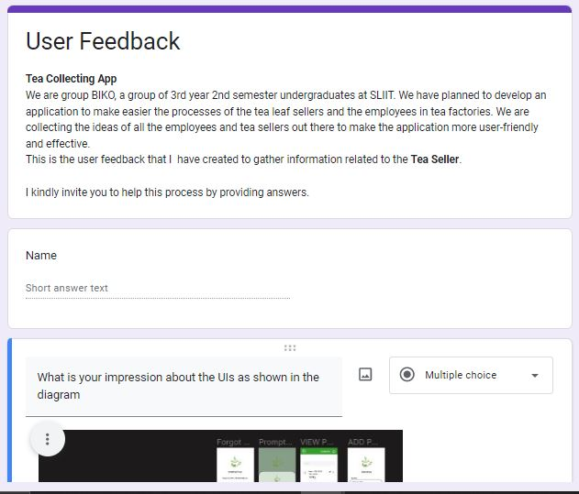

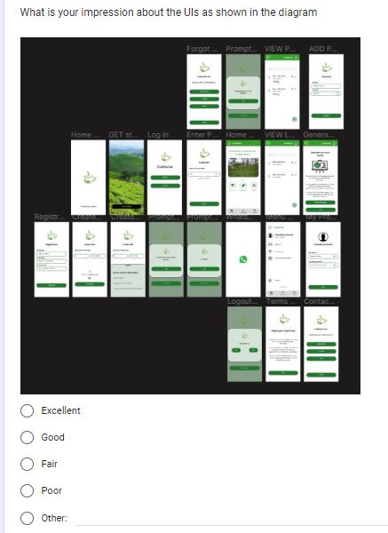

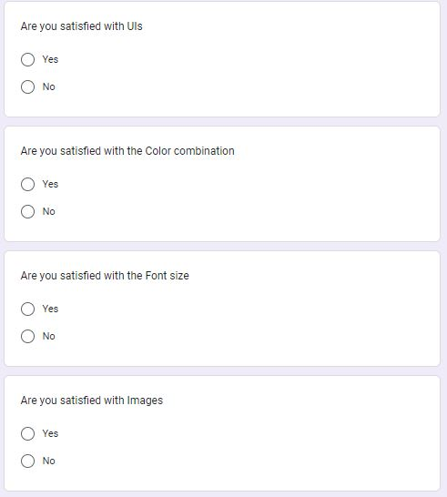

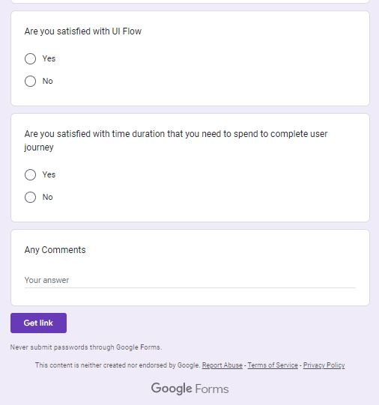

Responses :

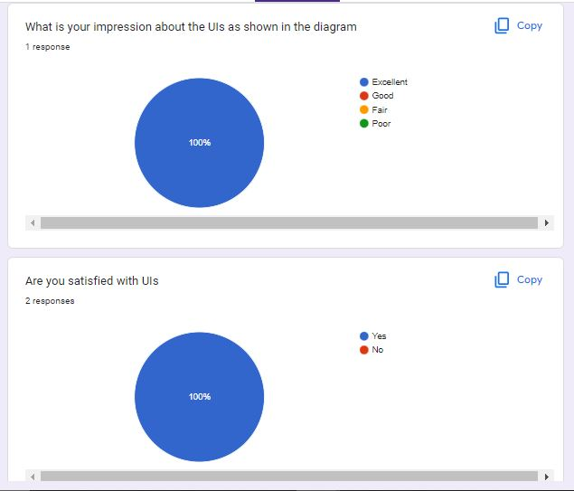

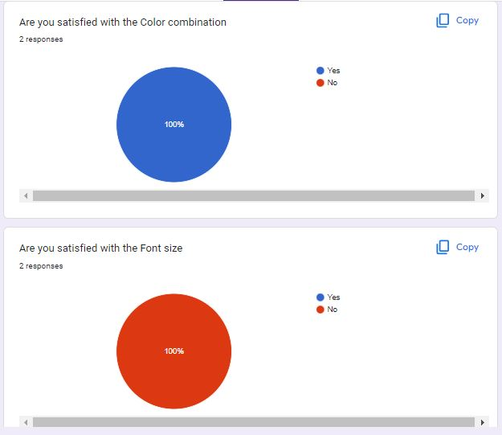

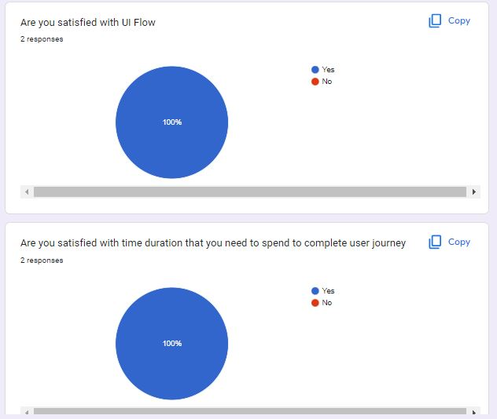

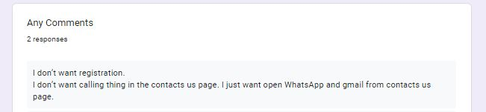

According to the user feedback 100% of both qualitative and quantitative factors are fulfilled

In here we consider the Likes and dislike impressions and requests that are gain from the customer and they requested some improvements.

**Conclusion:**

* Need to change the front size
* Need to remove registration.
* Need to remove call button in contact us page